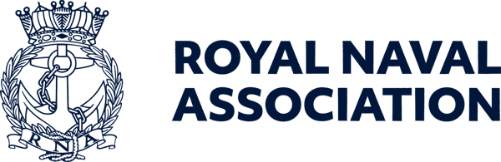

Semaphore Short Friday 21 August 2026

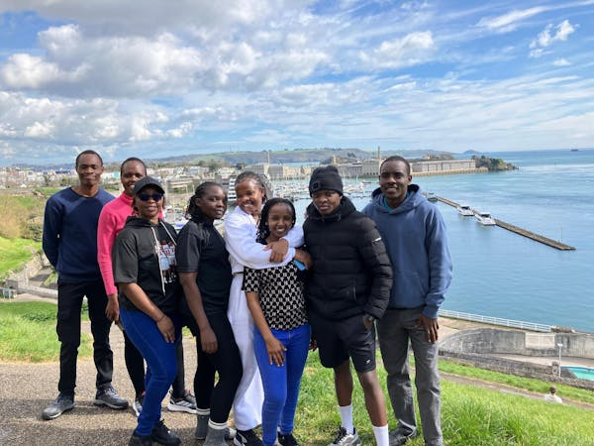

Boost a Recruit scheme gathers pace

At the Royal Naval Association, we know how important family connections are during training. That's why we're encouraging our members and supporters to help us to Boost a Recruit.
The campaign helps those who have just joined the Royal Navy and who can't get home to family and friends during leave periods, ensuring they receive support and a reminder that the Naval family is always there for them.
By helping us to provide simple wellbeing treats and morale-boosting activities your donation can make a real difference during a challenging and rewarding time.
Whilst HMS Raleigh provides excellent training and support, there is still tremendous value in the little things that help lift morale, especially when many recruits have gone home and only a handful are still in Raleigh over leave periods.
Your contribution could help fund a pizza night, perhaps cinema tickets, or a social activity that brings the recruits together and strengthens camaraderie, resilience and wellbeing
These may seem like small gestures, but they can make a huge difference to a recruit's experience – simply knowing that someone cares enough to support them can provide a valuable boost during what could otherwise be a lonely time.
The campaign is now also backed by RNRMC, which has approved a grant of up to £1,500 to support the recruits.
If you'd like to help our future sailors feel valued and connected, please consider making a donation today – the link is: https://tinyurl.com/2x9he574

Are you game for a shot at a world title?

The clock is ticking… time to register your interest in taking a tilt at a world championship!
Hosted by the Royal Naval Association at the Royal Maritime Hotel in Portsmouth on Saturday 3 October, the World Uckers Championships is open for registration from 0900 to 1000, and players of any standard, from novice to expert, are welcome.
The first dice are cast at 0930, and spectators are most welcome to watch proceedings, which promise plenty of thrills and excitement.
You can enter the competition as a solo player or part of a team of two, and we are keen to see ships and establishments represented – you could be playing for the honour of your shipmates.
To help us plan, please register your interest by emailing ceo-ea@rnassoc.org with your name, contact details and whether you're entering solo or with a teammate.

CONA gathering in Portsmouth

People are stronger together, and the same goes for the associations and groups that represent their interests.
CONA – the Conference of Naval Associations – is meeting in Portsmouth next month, providing a forum for representatives of Naval associations across the UK to network, share ideas, strengthen connections and discuss issues of importance to the wider Naval community.
Is your association a member – and if not, would it benefit from joining?
The RNA recognises the importance of CONA – it is currently the elected leader and executive of the group – and the event in Portsmouth will be chaired by RNA National President Vice Admiral Duncan Potts.
Whether you are involved with an association, a Branch committee, or simply interested in the organisations that support the wider Naval family, CONA offers an opportunity to meet fellow members, hear from guest speakers and contribute to important discussions.
The gathering is on Friday 11 September between 1300 and 1700, and lunch is included. For more information and to book a place please contact Milly on ceo-ea@rnassoc.org
Please note – delegates qualify for a ten per cent discount when booking a room at the Royal Maritime Hotel if they quote CONA.
Please also contact Milly if you would like to know more about how CONA could help the members of your members.

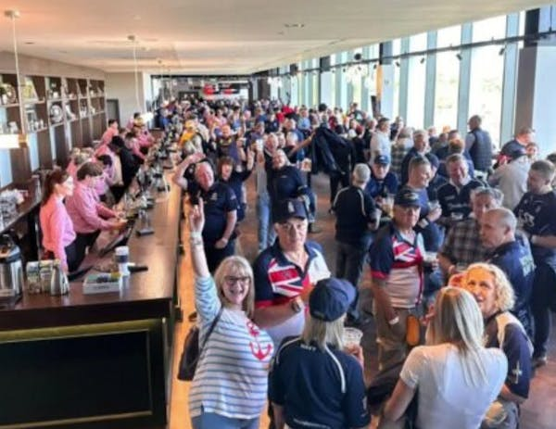

Big day out at Twickenham

The Royal Navy men’s rugby team are taking on the British Army at Twickenham next May, looking for a third victory in a row.
And if you would like to be there on Saturday 1 May to cheer them on, don’t fret – we are on the case.
We're delighted to confirm that the RNA's fantastic Members' Clubhouse Bar will once again be open for members, friends and family, and tickets will cover both the men’s match at 1400 and the women’s match which follows at 1645.
Even better, we'll once again have a dedicated RNA seating area, so you'll be able to enjoy the day alongside your fellow shipmates and share the experience as one fleet.
We’re currently finalising ticket arrangements and will be in touch soon with full details on how to secure your tickets through the RNA allocation.
Important: Please hold fire on purchasing tickets directly through the RFU. Those tickets won't form part of the RNA allocation, meaning you could find yourself separated from the rest of the RNA contingent.
Keep an eye on your inbox for further updates. We'll be in touch soon!

Are you pension aware?

Your Armed Forces pension is one of the most valuable benefits of Service, but how well do you understand yours?
As part of the MOD's Pension Awareness Week 2026, the White Ensign Association (WEA) is hosting a free live webinar for serving personnel, reservists and veterans, covering AFPS 75, 05 and 15, plus Early Departure Payments.
WEA Armed Forces Pension experts Dave Scholey and Marty Small, themselves Royal Navy and Royal Marines veterans, will explain the schemes, what they mean for their members and answer questions throughout the live session.
The webinar will be held on Wednesday 16 September, 1300–1430, online via MS Teams.
Know your scheme. Know your entitlements. Know your choices. Be pension aware!
You must register to attend: https://events.teams.microsoft.com/event/317d7a71-f9e3-48e1-a572-119a56acfd70@9e902c46-439c-4b5d-b4ae-572ded6ed2b9

More details of Central Office work

Central Office occupies one of Portsmouth Dockyard’s historic buildings, which is about to have some significant work carried out to it.
This will include a repair to the roof, and prior to the building work, an asbestos survey is to be carried out before it is repaired.
This will be followed by a complete re-wire of the building.
This process will begin on Monday 21 September and will last up to 11 weeks, meaning the Central Office team will have to vacate the building and relocate for this entire period.
Whilst we will make every effort to maintain business as usual, you may very well experience some delays and responses to questions that you may need an answer to.
We are currently investigating the possibility of diverting our office phone number to a temporary office, but this will be confirmed nearer the time.
Please accept our apologies for any disruption, and thank you all for your patience and understanding.



Exclusive book offer for RNA members

The Royal Naval Association is delighted to offer members an exclusive opportunity to purchase a signed hardback copy of best-selling author Hugh Sebag-Montefiore’s acclaimed book Battle of the Arctic for just £22 plus postage.
This special, limited-time offer has been arranged exclusively for RNA members ahead of Hugh’s visit to the Conference of Naval Associations (CONA) in September.
To secure your signed hardback edition, simply email: ceo-ea@rnassoc.org. Copies are available on a first-come, first-served basis and this exclusive RNA member offer is expected to generate considerable interest.
Battle of the Arctic shines a light on one of World War 2’s most demanding and often overlooked campaigns: the Arctic Convoys, described by Churchill as “the worst journey in the world.”
The book chronicles the extraordinary experiences of Royal Navy personnel and merchant seamen tasked with delivering vital arms, supplies and aid to Northern Russia through some of the harshest conditions imaginable. Navigating the treacherous Barents Sea north of Norway, convoy crews battled fierce storms, snow, ice, dense fog and dangerous Arctic waters, all while facing relentless enemy attacks including land-based bombers, powerful warships such as Tirpitz and Scharnhorst, and U-boats.
RNA members can also register their interest in attending either of Hugh’s upcoming speaking engagements:
- Conference of Naval Associations (CONA) – 11 September
- RNA Fireside Chat – 2 November
To purchase a signed copy of the book or register for either event, please email: ceo-ea@rnassoc.org
Don’t miss this opportunity to own a signed edition of this compelling wartime history and learn more about one of the most remarkable chapters of the war.

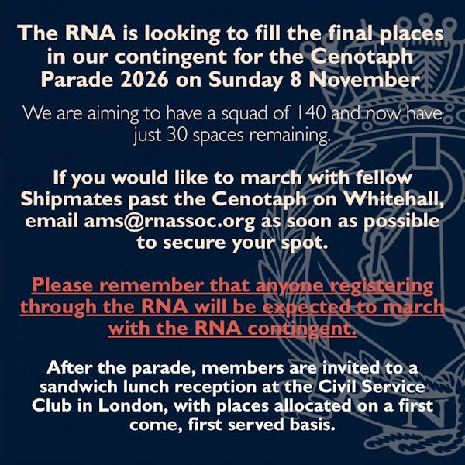

Remembrance registration

We still have a limited number of places remaining in the RNA contingent which will march along Whitehall in London on Remembrance Sunday.
Any shipmates interested in marching with the RNA at the November ceremonies in London should register their interest by emailing JB at ams@rnassoc.org no later than 15 September.
Please note – those registering with the RNA will be expected to march with the 140-strong RNA contingent.
In order to march you must possess at least one of the following:
• Veterans Recognition (ID) Card
• Veterans UK Status Card
• Certificate of Service – this must include date of discharge
• Certificate of Discharge
• Veterans Railcard
• For Merchant Mariners – a copy of the personal details page of your Discharge Book, along with the vessel names on which you served and the operation names and date.
Please check the RBL website for eligibility details: https://tinyurl.com/c9w445fa
Remembrance Sunday this year is 8 November.
Following the Cenotaph parade, the RNA will host a sandwich lunch reception for 50 members (on a firstcome, first served basis) at the Civil Service Club at 13-15 Great Scotland Yard, London SW1A 2HJ.



Fancy a trip to the Maldives?

This summer, Royal Navy & Royal Marines Charity is one of the beneficiary charities of the RaiseHero 50/50 Raffle.
Enter from just £5 for your chance to win incredible prizes – including a holiday for two in the Maldives – while helping to support those who serve in the Royal Navy, Royal Marines and Royal Fleet Auxiliary.
The main draw takes place on 30 September, with the prize being a luxury Maldives holiday for two, promising white-sand beaches, crystal-clear waters and £10,000 cash to spend. Or you could take home a £20,000 cash alternative.
And if you spend £25 or more you’ll be entered into a bonus draw to win £1,000 cash.
There are also weekly bonus prizes, so the earlier you enter, the more bonus draws you'll be eligible for the following:
- iPad – 26 August
- Apple smartwatch – 2 September
- Fortnum & Mason hamper – 9 September
- Ninja coffee machine – 15 September
- Nintendo Switch – 22 September
Every entry supports the Royal Navy & Royal Marines Charity, with 50 per cent of tickets purchased helping those who serve, have served, and their families.
For full details of the raffle and rules see https://tinyurl.com/y4cpkfpp

 |  |  |  |  |  |  |  |  |  |  | 

